ShopNest Store Power BI Capstone Report

1. Introduction:
ShopNest is an leading department store in e-commerce marketplace in Portugal. The Questions Statement of this project is to design a comprehensive business intelligence dashboard using Power BI to analyze sales performance, delivery efficiency, payment behavior, customer satisfaction for each product category, and regional sales trends yearly and quarterly.
The dataset consists of 9 relational tables including customers, orders, order items products, payments, reviews, sellers, and geolocation information. After cleaning and modeling the data, visualizations were built to answer key analytical questions.

2. Data Cleaning and Transformation:
The datasets were imported into Power BI and transformed using Power Query.
Data cleaning steps included:
• Removing duplicate records from primary key columns.
• Converting numeric fields (price, payment value, freight value) to decimal format.
• Converting timestamp columns into proper date/time data types.
• Creating relationships between datasets to form a star schema model.
These transformations ensured accurate calculations and reliable reporting.

3. Data Model / Creating Relationship Between Tables:
The data model connects multiple tables through key relationships:
Customers → Orders → Order Items → Products
Orders → Payments
Orders → Reviews
Order Items → Sellers
Products → Category Translation
This relational model enables analysis across sales, logistics, customer feedback, and product performance.

4. Creating Key Measures (using DAX):
Total Revenue, Total Orders, Delayed Orders, On-Time Orders, Average Review Score, and other columns to find year, month and quarter to drive insights.

5. Task 1: Top Product Categories by Sales:
Questions Statement: Identify the top 10 product categories based on total sales value.
Method: A clustered bar chart was used to visualize total sales aggregated by product category.
Calculation: Total Sales = SUM(order_items[price])
Visualization: 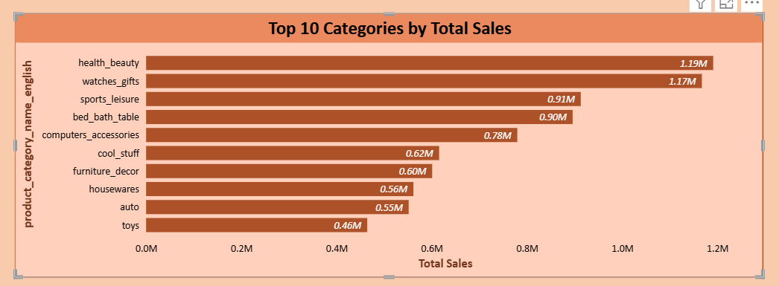
Explanation: The top-performing categories generate the largest portion of revenue, indicating those category products have strong customer demand.

5. Task 2: Delayed Orders Analysis:
Questions Statement: Determine how many orders were delivered later than the estimated delivery date in each product category.
Method: Actual delivery dates were compared with estimated delivery dates.
Calculation: CALCULATE(
COUNT(orders[order_id]),
orders[order_delivered_customer_date] >
orders[order_estimated_delivery_date]
)
Visualization:
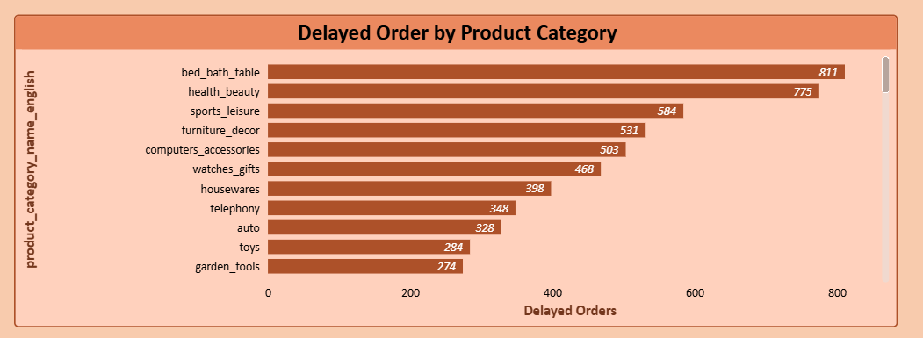
Explanation: This metric evaluates logistics performance and helps identify shipping delays.

6. Task 3: Monthly Comparison of Delayed vs On-Time Orders:
Questions Statement: Compare the number of delayed and on-time orders for each month.
Method: A clustered column chart was created using month as the time dimension.
Visualization:
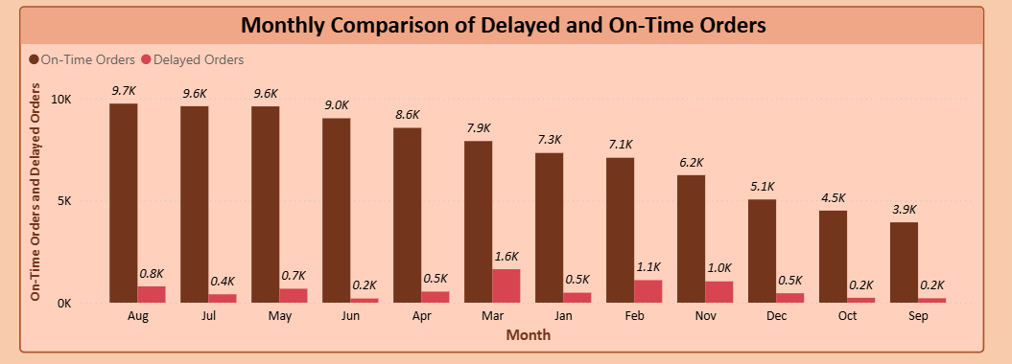
Explanation: Monthly comparison highlights periods where delivery performance declined and helps identify seasonal logistics challenges.

7. Task 4: Payment Method Analysis:
Questions Statement: Analyze most frequently used payment methods by customers.
Method: A pie chart was used to display the distribution of payment types.
Calculation: Total Payment Value = SUM(order_payments[payment_value])
Visualization:
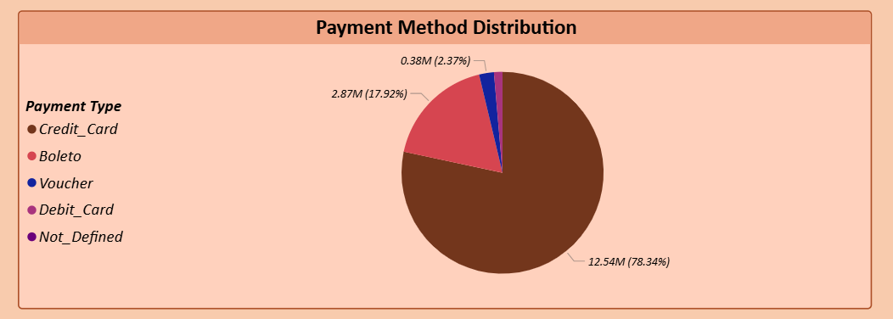
Explanation: Understanding payment method preferences by customers helps optimize checkout experiences and future targeted promotions.

8. Task 5: Product Rating Analysis:
Questions Statement: Determine Top 10 highest rated product category and bottom 10 lowest rated product category.

Method: A clustered bar charts were used to show top 10 highest-rated products and bottom 10 lowest-rated products.
Calculation: Average Rating = AVERAGE(order_reviews[review_score])
Visualization:
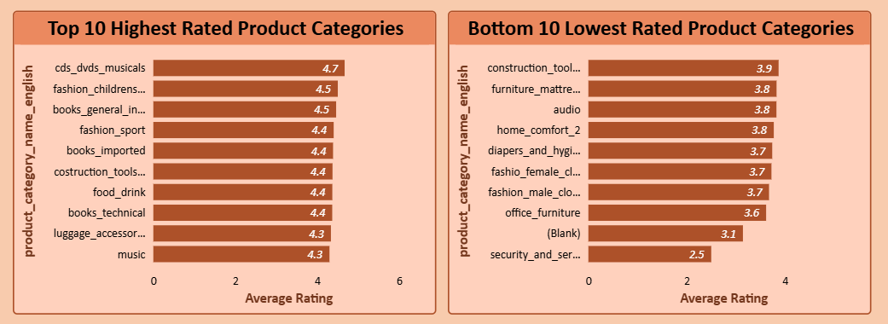
Explanation: Highly rated products indicate strong customer satisfaction, while low ratings reveal areas needing improvement.

9. Task 6: State-wise Sales Analysis:
Questions Statement: Analyze revenue distribution across states.
Method: A map visualization was used to display total sales by customer state.
Visualization:
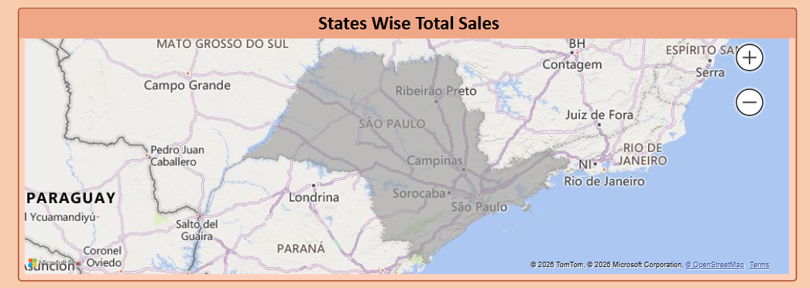
Explanation: Regional sales analysis helps identify high-performing markets and potential expansion opportunities.

10. Task 7: Seasonal Sales Patterns:
Questions Statement: Identify quarterly(seasonal) sales patterns.
Method: A line chart was used to track revenue across quarters.
Calculation: Total Revenue = SUM(order_payments[payment_value])
Visualization:
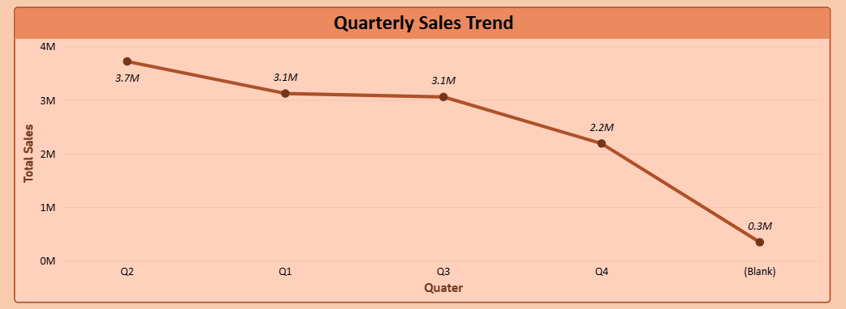
Explanation: Seasonal trends provide insights into demand cycles which help improve inventory and marketing strategies.

11. Task 8: Revenue Trend Analysis:
Questions Statement: Evaluate how revenue changes over year.
Method: A yearly revenue trend line chart was created.
Visualization:
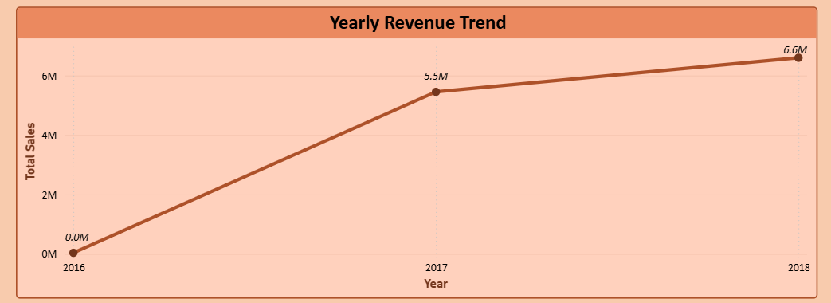
Explanation: Revenue growth trends help assess long-term business performance and strategic planning.

12. Conclusion:
The Power BI dashboard provides a complete analytical overview of ShopNest's departmental store business performance. Key insights include top-performing product categories, delivery efficiency, customer payment behavior, regional sales distribution, and seasonal revenue patterns, highest and lowest rated product categories.
These insights support better decision-making for logistics, marketing, inventory management, and customer experience improvements.

